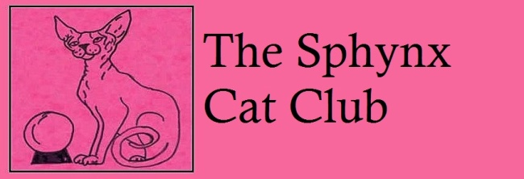
WEBSITE www.sphynxcatclub.co.uk
FB sphynx cat club official group
EMAIL amarogue@talktalk.net
APPLICATION FOR MEMBERSHIP
Single £5. Joint £7. Senior £3. Senior Joint £6. Junior £3.

Name...........................................................................................................................................
Address........................................................................................................................................
....................................................................................................................................................

Tel....................................Prefix...................................................Date.........................................
Email...........................................................................................................................................
Junior Members must be under 16yrs. DOB.............................................................................
.
Name of proposer.......................................................................................................................
Proposers Signature.....................................................................................................................................
CHEQUES/POSTAL ORDERS to be made payable to Sphynx Cat Club and return to Club Secretary 72.Hillside Drive, Christchurch, Dorset BH23 2TA

By ticking the box you give the club consent to keep your information on record and agree to being contacted regarding club affairs.
you may opt out at any time by emailing amarogue@talktalk

